**4CS401: Cryptography and Network Security**

**B.Tech. (CSE) – I [ 2022-23 ]**

**Assignment**

**Generation of digital Certificate**

**Title: Generation of digital Certificate**

**Aim: To Demonstrate Generation of digital Certificate**

**Theory:**

**Generation of digital certificate using java key tool and key store utilities or by using open SSL**

**By using below command we will create jks file.**

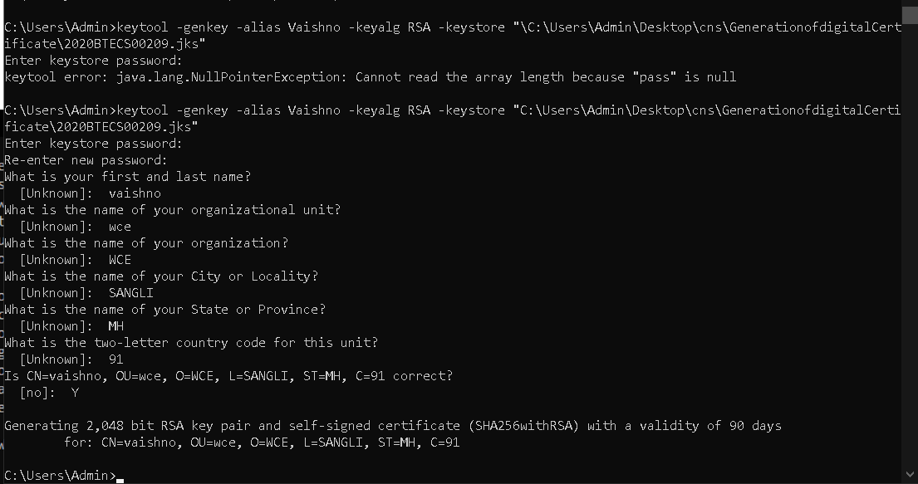

**Your can see jks file is created here .**

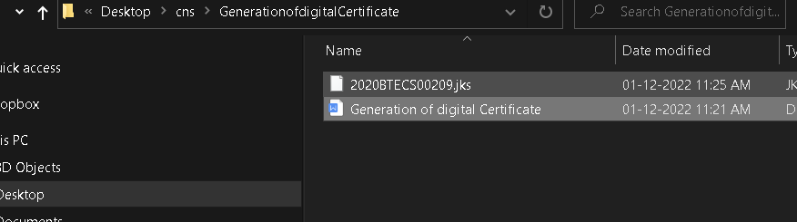

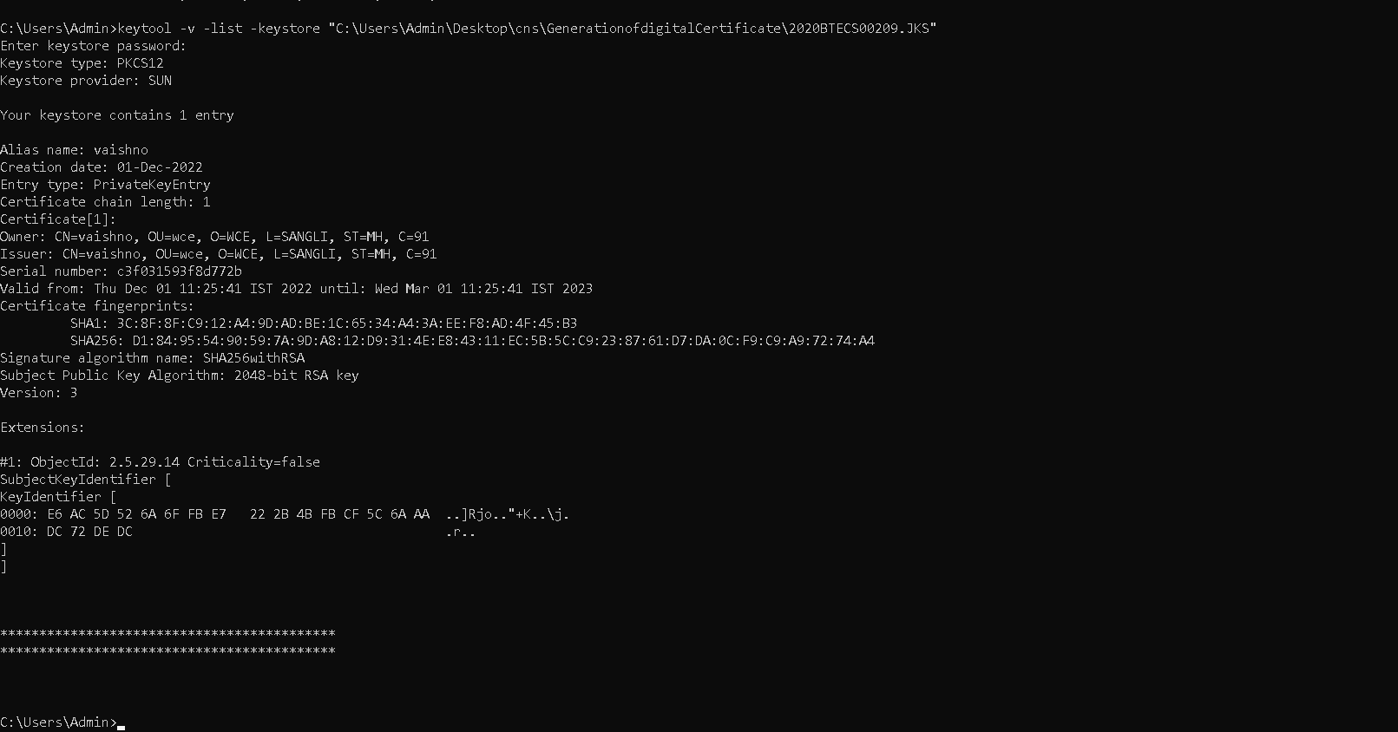

**NOw will create digital certificate.**

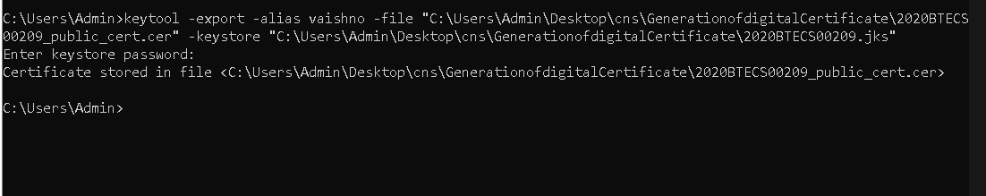

**This is digital certificate created,**

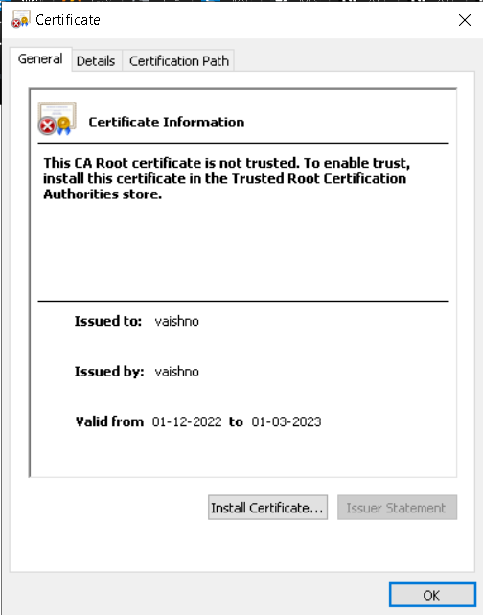

**Applications :**

* **Digital certificates are used for to secure email to identify one user to another**
* **It may also used for electronic document signing.**